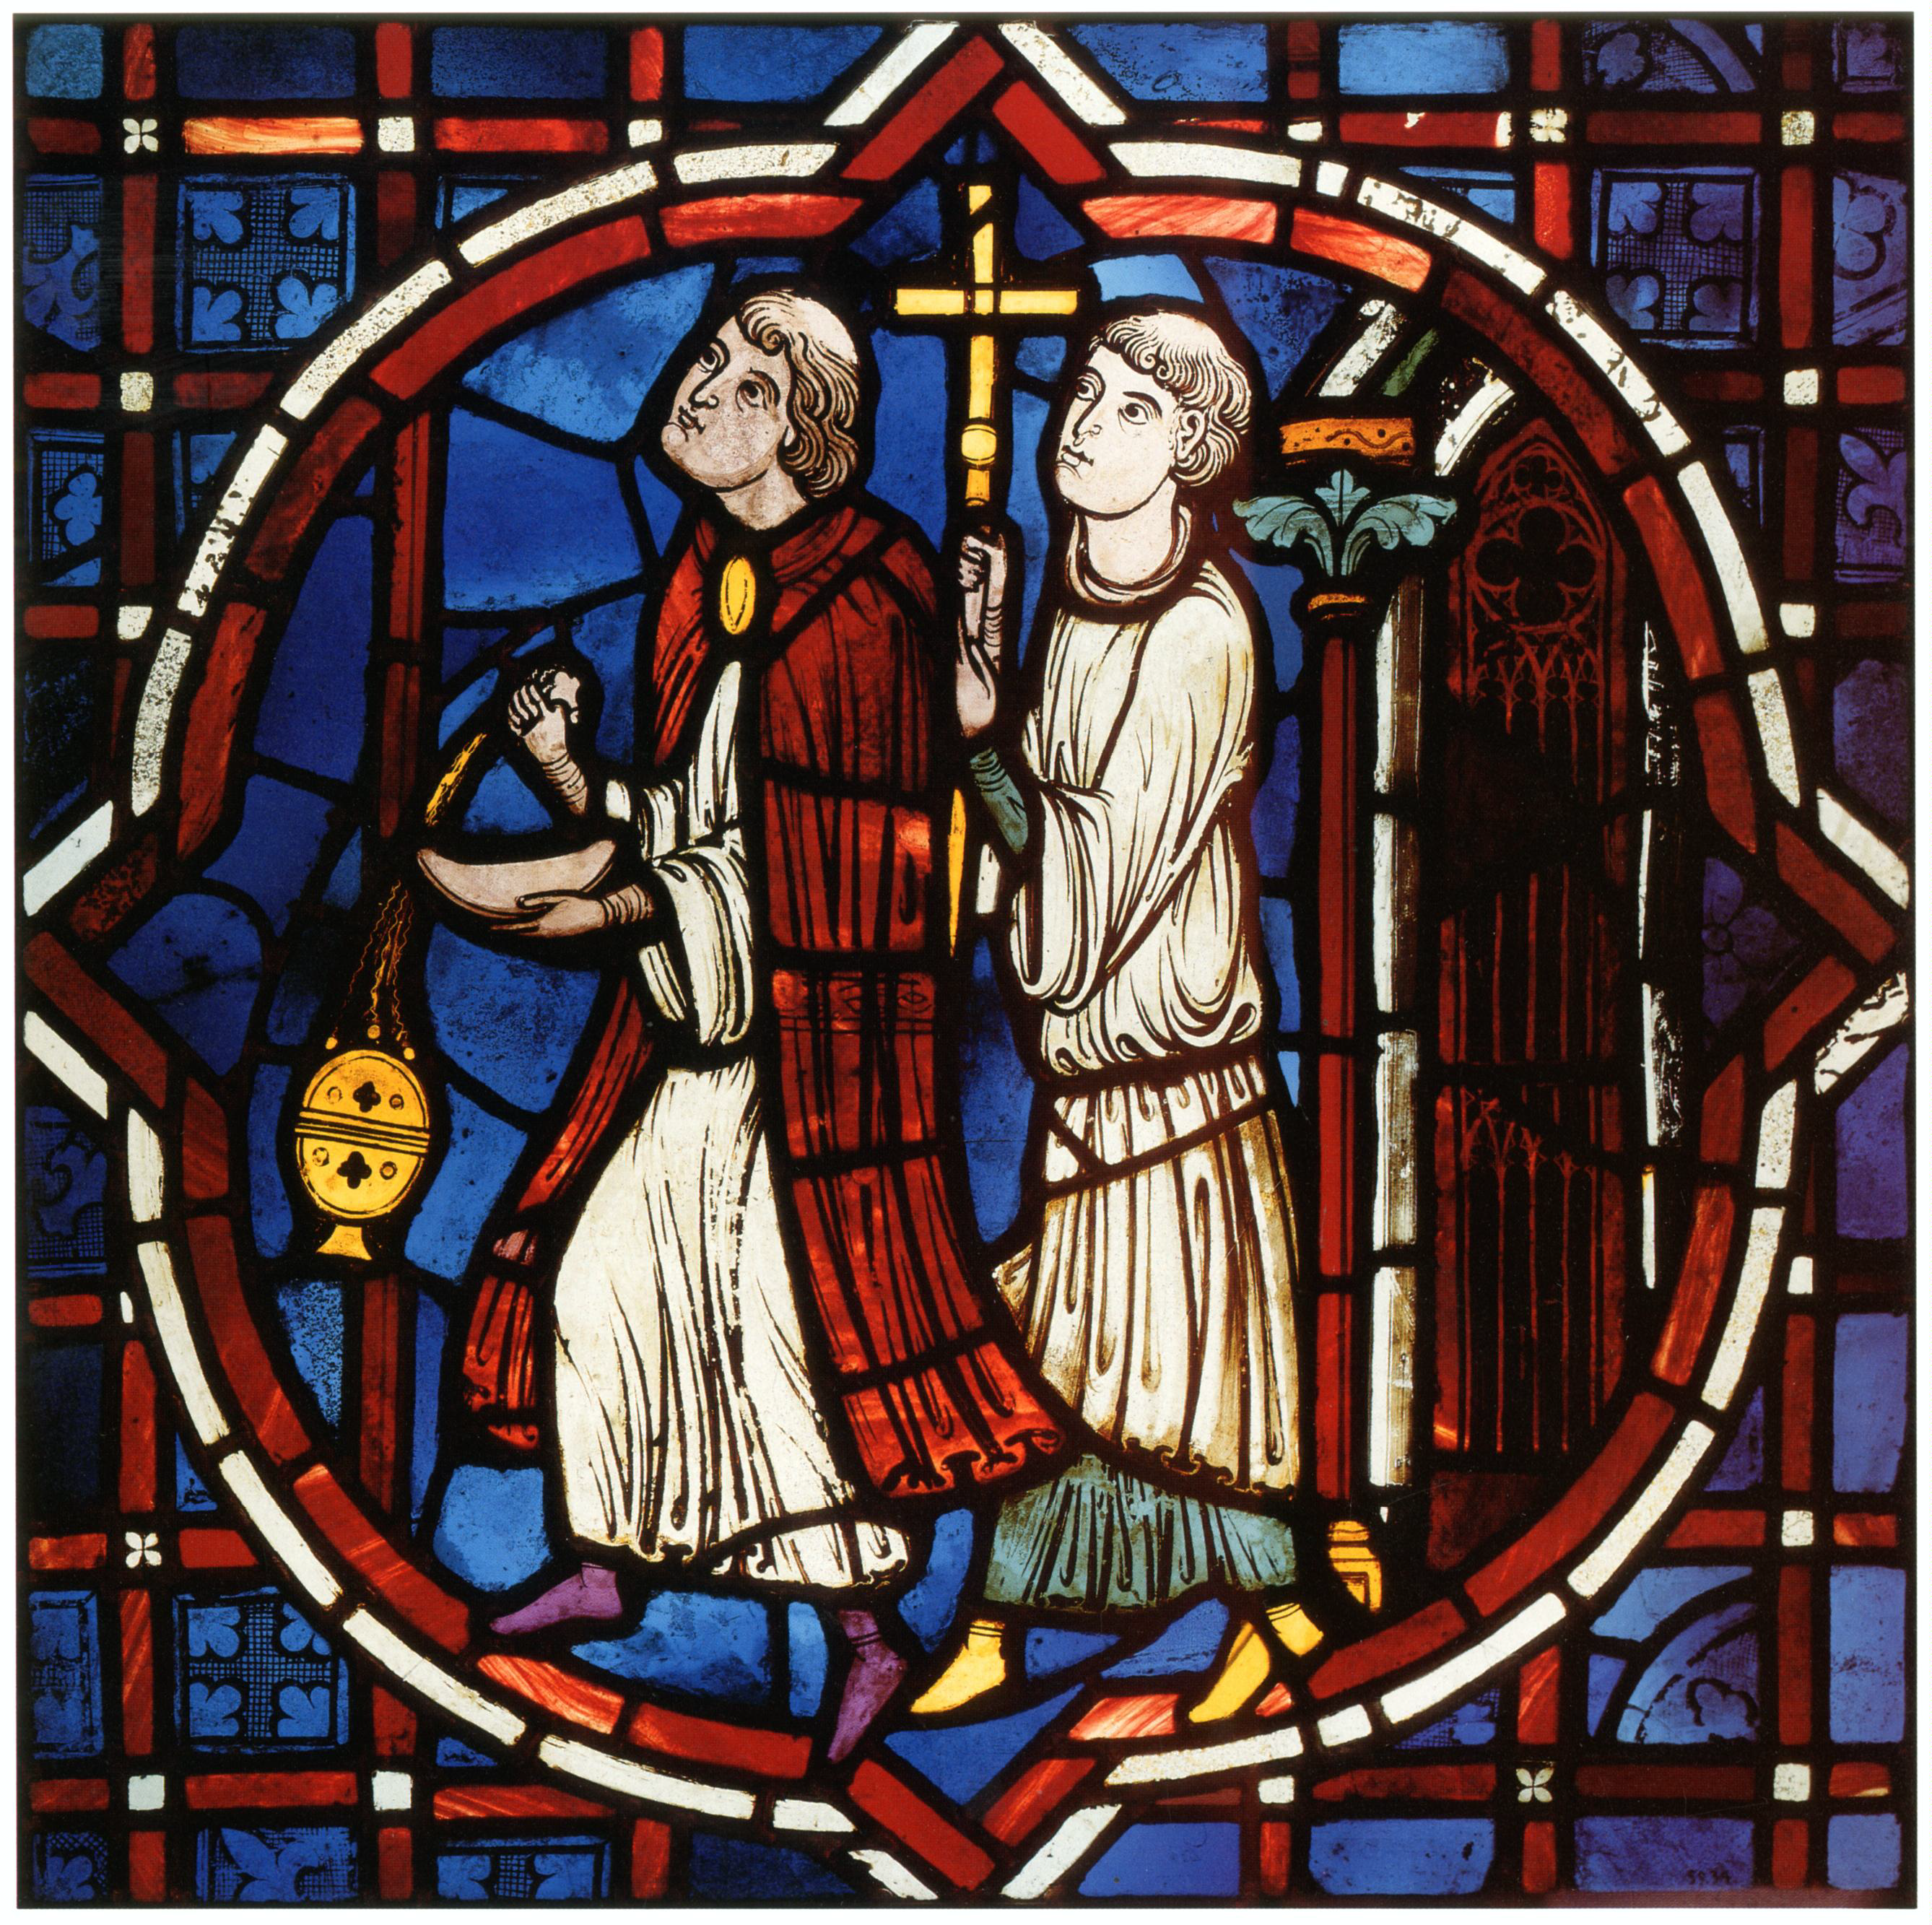
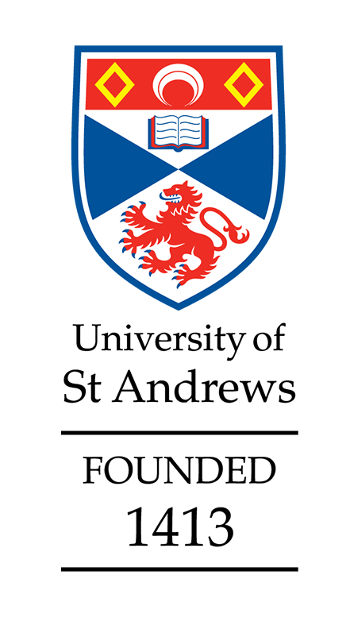
Centre for French History and Culture
Biannual Lecture

Dr Cecilia Gaposchkin
(Dartmouth College)

‘Nivelon of Soisson, the relics of 1204, and the Cathedral of Soissons: liturgy and devotion in the aftermath of the Fourth Crusade’

After the sacking on Constantinople during the Fourth Crusade, one of the crusade’s ecclesiastical leaders, Nivelon of Quierzy, sent to his home church, the Cathedral of Soissons, a huge cache of important apostolic relics. This paper explores the effect that the arrival of these relics had on the city’s lay and clerical community. By reconstructing the shifts in the liturgy and other aspects of the church’s ceremonial, Gaposchkin will demonstrate how the relics affect the devotional and cultural life of the city.

5.15pm, Wednesday 9 November
New Seminar Room (69-71 South Street)

All welcome! / Tous sont les bienvenus !
Centre for French History and Culture cffhc@st-andrews.ac.uk

